RFC: Unified Web Runtime
Convergence Architecture
Platform Engineering · Web Platform Team
September 2026 · DRAFT

Status: Draft for review
Applies to: CBx Channel · JPMM Channel · All channel teams

Summary
Today, CBx and JPMM are served by two independent web channel stacks. Channel teams build every experience twice. This RFC proposes converging both channels onto a single, versioned Web Runtime delivered from CDN and backed by a lightweight Web Runtime Service (Go) and a Web Runtime Config Service. The result: one runtime, one config surface, one deploy pipeline — channel teams build once.
 | Details
Problem | Two channel stacks · channel teams build every experience twice · no shared config surface
Solution | Single versioned Web Runtime (CDN) · Web Runtime Service (Go BFF) · Web Runtime Config Service
Timeline | 32 weeks across 5 phases
Teams affected | CBx platform, JPMM/OCS platform, all channel teams, DE Console

Current State
Two separate channel stacks exist today with no shared runtime or config surface.

CBx Channel
- OIDC Shell App — handles auth flow AND serves index.html (tightly coupled; must be decoupled)
- Resolver (Java + OPA) — evaluates config and access control; integrated with Redis and Registry
- Registry — tracks module versions sourced from CDAaS; triggers auto-patch
- CBx Web Runtime — channel-specific browser bundle; to be replaced
- CDAaS — Content Delivery as a Service; already converged; retained unchanged

JPMM Channel
- OCS (Omni Channel Service) — platform-team-owned; serves index.html today
- Runtime metadata DB — JPMM-specific schema
- Profile service + Entitlements — JPMM-specific integrations
- JPMM Web Runtime — channel-specific browser bundle; to be replaced
- Console — config authoring for JPMM; integrated with OCS

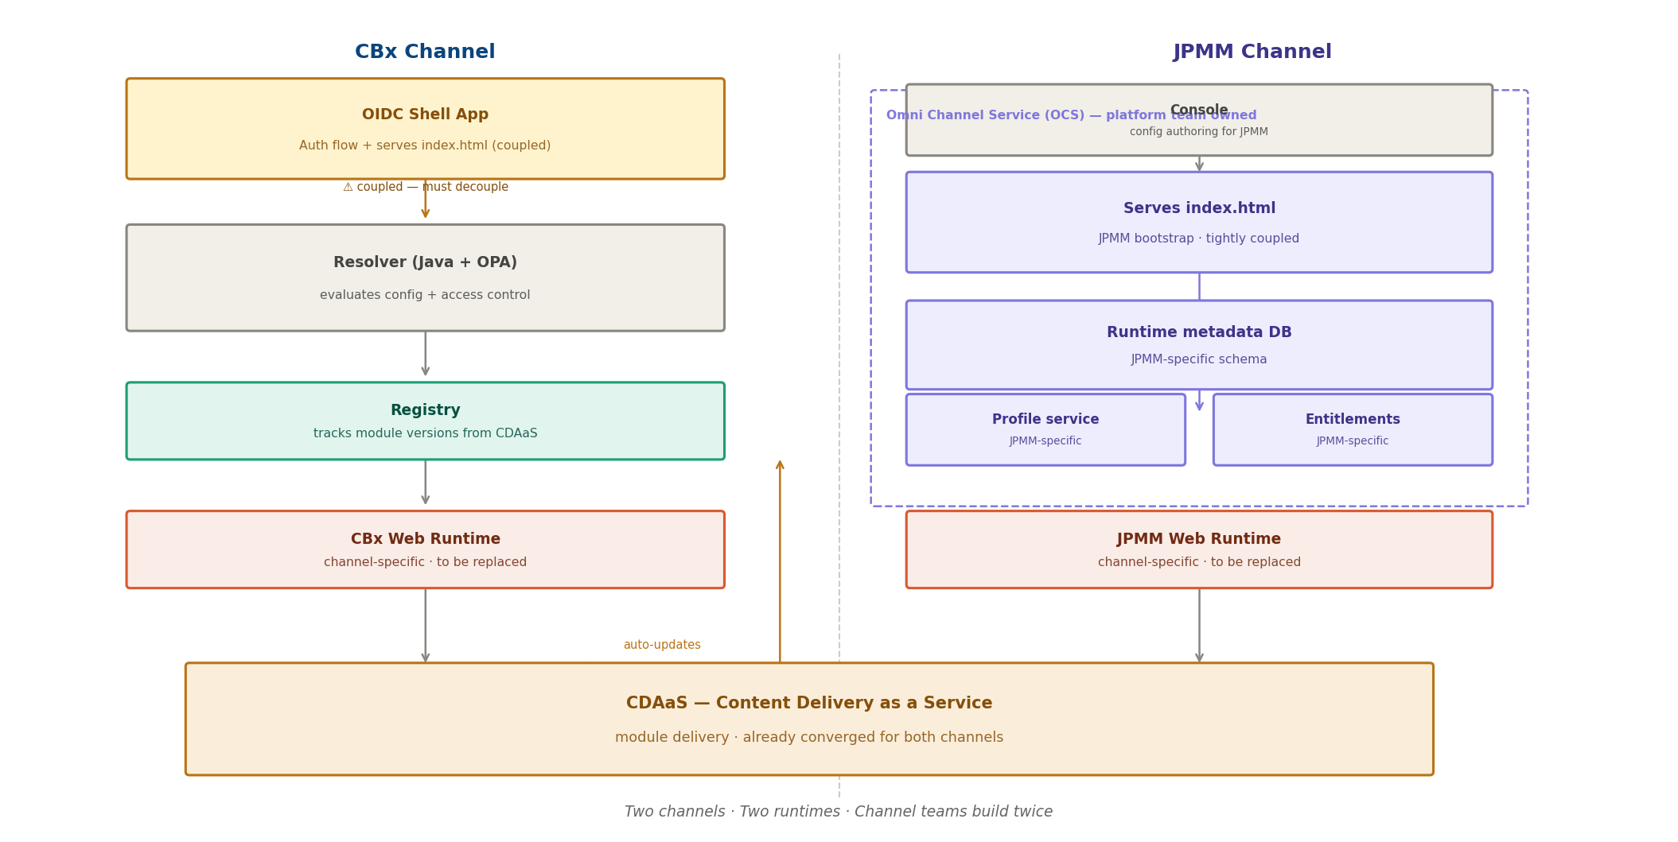
Figure 1 — Current State: two channels, two runtimes, channel teams build twice
The key friction: CDAaS is already shared and working. Everything above it is duplicated.

Why a Unified Web Runtime Platform
Two channels sharing the same mission — deliver personalised web experiences to users — today run entirely separate stacks. Every platform capability is built twice. Every incident is investigated twice. Every runtime improvement is deployed twice.
A unified web runtime platform changes this. It is a single versioned runtime, a single config surface, and a single deploy pipeline. Channel teams build experiences once. Platform improvements benefit both channels immediately. The platform team owns one surface — not two.
The platform must be designed for both channels from the start. The web runtime service uses pluggable channel adapters so each channel's auth, profile, and entitlements integrations are first-class. OCS team alignment and co-design of the JPMM adapter is required before Phase 5 work begins; this RFC is a proposal to the OCS team, not a mandate.

Platform Capabilities
The unified web runtime platform delivers the following capabilities across both channels.
# | Capability | How the platform delivers it
1 | Multi-tenant config per LOB | One manifest per tenant, isolated per environment
2 | Immutable versioned storage | Every publish creates a new immutable version; full history retained in WRCS
3 | Environment isolation | Separate staging and production config slots per tenant
4 | Blue-green promotion | Candidate and stable slots per tenant; promote with one API call
5 | Schema validation | Manifest validated at publish time; invalid config rejected before reaching users
6 | Event emission | WRCS emits on config change; web runtime service cache invalidated automatically
7 | CDAaS integration | Registry auto-patches module version pointers in manifest on every CDAaS deploy
8 | External publish API | CLI, CI/CD pipelines, and DE Console publish manifests via REST API
9 | Instant rollback | Any previous manifest version restorable in seconds via API; no redeployment
10 | Diff tracking | WRCS records what changed between versions for audit and debugging

Architecture Goals
Derived from first principles — each goal answers a question that any web platform must answer:
- G1 — Build once, deploy everywhere: channel teams write one experience; it runs on all channels
- G2 — Fast first paint: server renders index.html with all boot data injected; zero extra round trips before render
- G3 — Config is versioned and immutable: every manifest snapshot is stored, diffable, and rollback-capable
- G4 — Auth is separate from delivery: OIDC shell validates JWT; it does not serve index.html
- G5 — Runtime is independently versioned: browser bundle is CDN-delivered and can be canary-upgraded per tenant
- G6 — Module delivery is already solved: CDAaS continues unchanged; manifest tracks version pointers only
- G7 — Access control is embedded, not networked: OPA policies evaluated in-process; no extra hop

Target Architecture
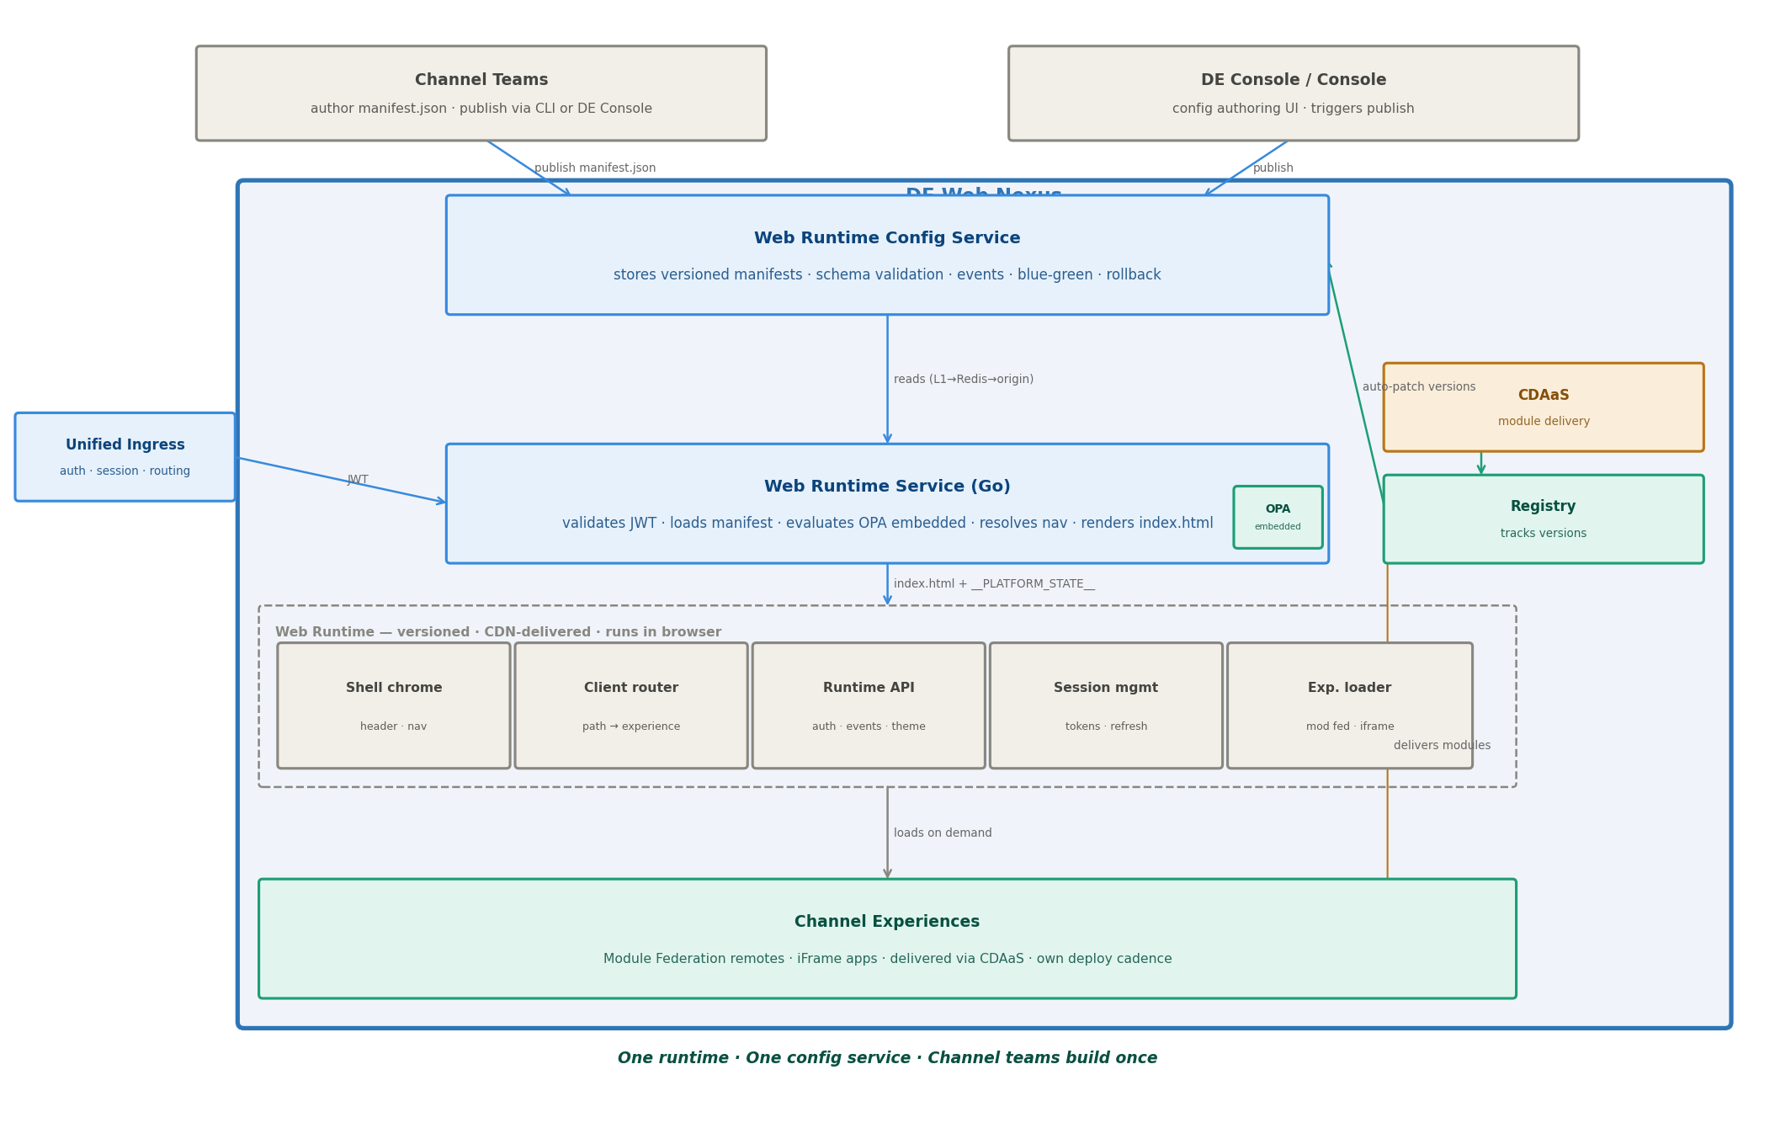
Figure 2 — Target Architecture: one runtime, one config service, channel teams build once

Request Flow
1. User hits tenant domain → OIDC Shell validates JWT, passes token to Web Runtime Service
2. Web Runtime Service reads manifest from Web Runtime Config Service (L1 cache → Redis → origin)
3. OPA evaluates access control in-process against the token and manifest permissions
4. Web Runtime Service renders index.html with __PLATFORM_STATE__ injected
5. Browser loads Web Runtime from CDN; reads __PLATFORM_STATE__; no extra API calls needed
6. Web Runtime's experience loader lazy-loads product experiences from CDAaS on demand

Key Components
Component | What it does | Status
Web Runtime | Versioned browser orchestrator: shell chrome, client router, platform bus, experience loader. CDN-delivered. | New (replaces CBx + JPMM runtimes)
Web Runtime Service (Go) | BFF: validates JWT, reads manifest, evaluates OPA, resolves nav, renders index.html + __PLATFORM_STATE__ | New (evolves from Resolver)
Web Runtime Config Service | Stores versioned manifests per tenant per env. Schema validation, blue-green slots, rollback, event emission. | New
manifest.json | Config file teams author. Declares nav, experiences, chrome config, permissions, runtime version. | New artefact
OIDC Shell | Auth only. JWT validation. Does not serve index.html. | Retained (decoupled)
Registry | Tracks module versions from CDAaS. Triggers auto-patch of manifest version pointers. | Retained
CDAaS | Module delivery. Already converged for both channels. | Retained unchanged
OPA | Access control evaluation embedded in Go binary. Scope narrowed from config+access to access only. | Retained (scope narrowed)
OCS | Omni Channel Service. Serves JPMM today. Retired in Phase 5. | Retired
Resolver (Java) | Config + access evaluation. Evolves into Web Runtime Service. Retired in Phase 3. | Retired

The manifest.json

What It Is
manifest.json is the single config file that a channel team authors to declare everything the platform needs to serve their experience: nav structure, which experience loads at which path, shell chrome config, required permissions, and which runtime version to use.

Schema (abbreviated)
{
"version": "1.0",
"tenantId": "retail-checkout",
"env": "production",
"runtime": { "version": "1.7.0", "upgradePolicy": "auto-patch" },
"shell": {
"header": { "logo": "https://cdaas.../logo.svg", "height": 56 },
"nav": [{
"id": "overview", "label": "Overview", "icon": "home",
"path": "/overview", "default": true, "permission": null,
"experience": {
"type": "module-federation",
"remote": "https://cdaas.../remoteEntry.js",
"scope": "overview", "module": "./App",
"moduleVersion": "3.1.2", "deployedAt": "2026-09-20T01:00:00Z"
}
}],
"auth": { "required": true, "roles": ["checkout-user"] }
}
}

Lifecycle
- Teams publish channel configuration via API client (CI/CD pipelines) or DE Console UI — both call the same WRCS API
- Web Runtime Config Service validates schema, stores immutable snapshot, emits config-changed event
- When a module is deployed to CDAaS, Registry detects the new version and auto-patches the moduleVersion pointer — teams do not need to republish for routine module deploys
- Structural changes (add/remove nav, change permissions, change runtime version) require an explicit publish
- Blue-green: two slots per tenant per env (blue = stable, green = candidate); traffic split configurable
- Rollback: promote any prior immutable snapshot to active in one API call

Key Design Decisions
Decision | Rationale
Go for Web Runtime Service | Sub-millisecond HTML render; small binary; OPA embeds cleanly via go-opa; no JVM warm-up on cold start
OPA embedded, not networked | Eliminates extra hop on every request; policy bundle shipped with binary; evaluated in-process
manifest.json, not DB-first config | Config-as-code: versionable, diffable, code-reviewable, CLI-publishable; DB stores the snapshots
Immutable manifest snapshots | Rollback is atomic: promote a snapshot, not diff-patch; audit log is free
CDAaS unchanged | Module delivery is already solved and converged; adding a new layer would introduce risk with no benefit
OIDC Shell decoupled from HTML serving | Auth and delivery are separate concerns; decoupling enables independent scaling and failure isolation
OCS retired (not extended) | Extending OCS for CBx is effectively a rewrite inside a live production system; clean-slate build is lower risk

Phased Transition Plan
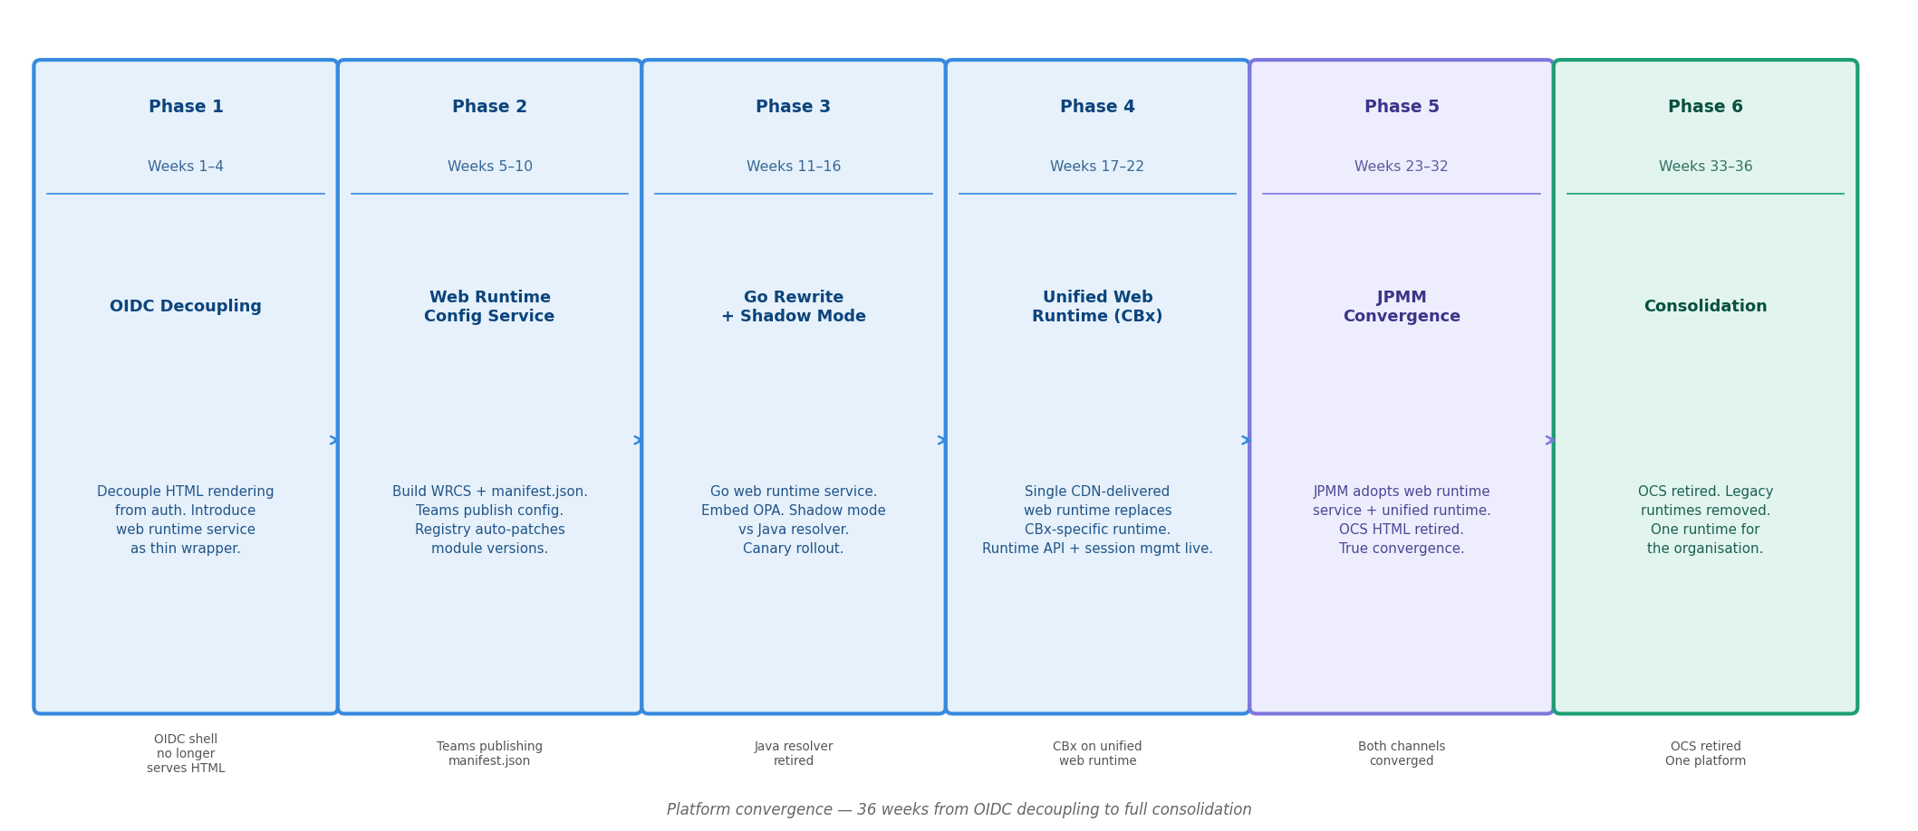
Figure 3 — Platform convergence: 32 weeks from OIDC decoupling to full consolidation
Phase | Weeks | Name | Key deliverables | Exit milestone
1 | 1–4 | OIDC Decoupling | Decouple HTML rendering from OIDC Shell. Introduce Web Runtime Service as thin wrapper calling existing Resolver. | OIDC shell no longer serves index.html
2 | 5–10 | Web Runtime Config Service | Build WRCS + manifest.json schema. Teams publish config. Registry auto-patches module version pointers. | Teams publishing manifest.json
3 | 11–16 | Go Rewrite + Shadow Mode | Go Web Runtime Service with embedded OPA. Shadow mode runs alongside Java Resolver. Canary rollout begins. | Java Resolver retired
4 | 17–22 | Unified Web Runtime (CBx) | Single CDN-delivered Web Runtime replaces CBx-specific runtime. Platform bus live. | CBx on unified Web Runtime
5 | 27–32 | Consolidation | OCS retired. Legacy runtimes removed. One runtime for the organisation. | OCS retired · One platform

Design-Time Flow: Channel Authoring & Manifest Publish
Channel teams configure their channel through one of two first-class authoring surfaces, both calling the same WRCS API. The Web Runtime Config Service validates the schema, stores an immutable snapshot, and places it in the candidate blue-green slot. After review, the team promotes it to stable — at which point the Web Runtime Service cache is invalidated and the new config is live. Module version updates happen automatically when CDAaS deploys a new version: Registry detects the deploy, patches the manifest, and emits a cache-invalidation event.

Authoring Surfaces
- Path A — API Client (CI/CD): Channel teams or their pipelines call the WRCS REST API directly. Enables config-as-code workflows, automated promotion gates, and programmatic channel management. Preferred for teams with mature CI/CD practices.
- Path B — DE Console (UI): Teams compose their channel configuration visually in the DE Console. The Console calls the same WRCS API under the hood — it is a UI client of the API, not a separate backend path. Preferred for teams that want a guided authoring experience.
- Both surfaces produce identical outcomes: a versioned, schema-validated manifest stored in the candidate slot. Teams can switch between surfaces at any time.
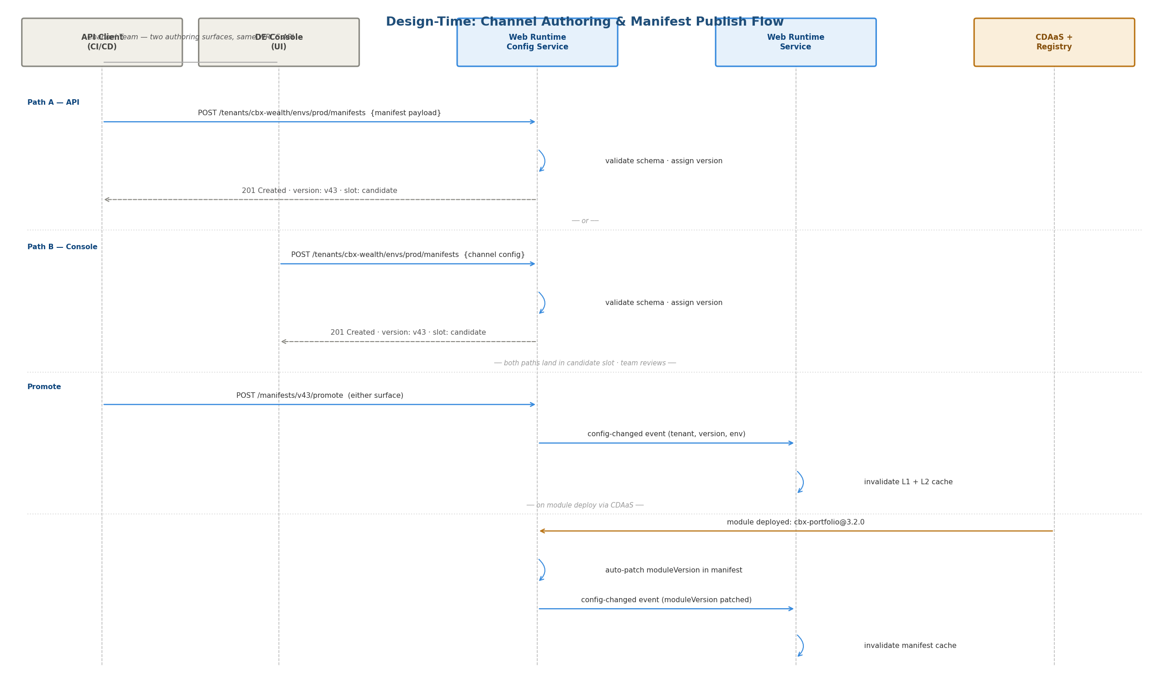
Figure 4 — Design-time: channel authoring via API or DE Console, blue-green promotion, and module auto-patch
- Publish is idempotent — identical manifest content produces the same version hash; WRCS deduplicates
- Schema validation runs at publish time; invalid manifests are rejected before they can affect users
- Candidate slot allows staging review; traffic stays on stable until the team explicitly promotes
- Module auto-patch (Registry → WRCS → cache invalidation) is transparent to channel teams — no republish needed for routine module deploys

Runtime Flow: Request Serving
Every user request flows through Unified Ingress for session validation, then to the Web Runtime Service which loads the manifest, evaluates access control via embedded OPA, and renders index.html with __PLATFORM_STATE__ pre-injected. The browser boots entirely from injected state — zero extra API calls before first render. The runtime bundle and experience modules are served from CDN.
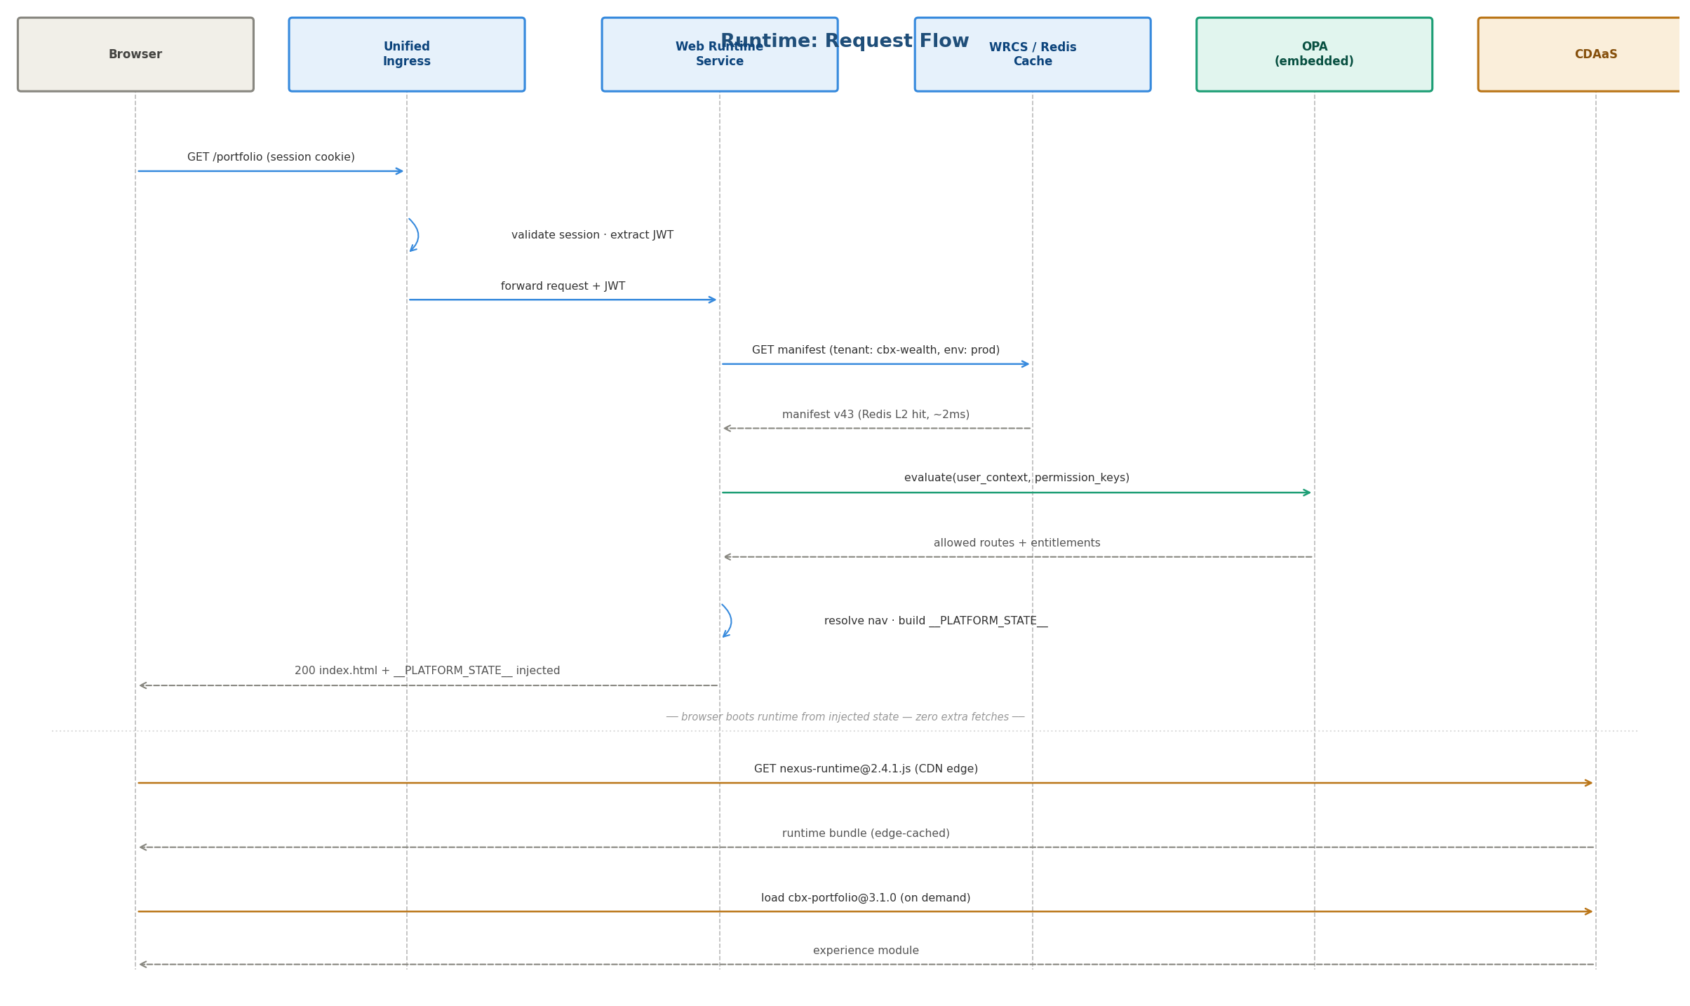
Figure 5 — Runtime: request path from browser hit to rendered index.html and experience load
Step | Actor | Detail
1 | Unified Ingress | Validates session cookie, extracts JWT, forwards request
2 | Web Runtime Service | Reads manifest from Redis L2 cache (~2 ms typical); falls back to WRCS origin on miss
3 | OPA (embedded) | Evaluates user_context + permission_keys in-process; no network hop
4 | Web Runtime Service | Resolves nav tree, builds __PLATFORM_STATE__, renders index.html
5 | Browser | Receives index.html + injected state; no extra fetches before render
6 | Browser → CDN | Loads versioned runtime bundle from CDN edge (edge-cached)
7 | Browser → CDAaS | Lazy-loads experience modules on navigation; own deploy cadence

Risks and Mitigations
Risk | Likelihood | Impact | Mitigation
Go service underperforms vs Java Resolver under load | Low | High | Shadow mode in Phase 3 validates latency at production traffic before cutover
OPA policy migration breaks access control | Medium | High | Policy tests run in parallel on both services during shadow period
Teams slow to adopt manifest.json | Medium | Medium | DE Console generates manifest from existing config; CLI with schema validation; migration tooling
Blue-green promotion causes cache inconsistency | Low | Medium | Manifest version pinned in index.html; cache-busted on promotion; CDN purge on slot swap
Web Runtime version mismatch between tenants | Low | Low | SemVer pinning in manifest; auto-patch policy configurable per tenant (pin vs auto)

